Download and import HDP into your virtual box and explain how Ambari is useful and the features of Ambari.

**Installing ambari:**

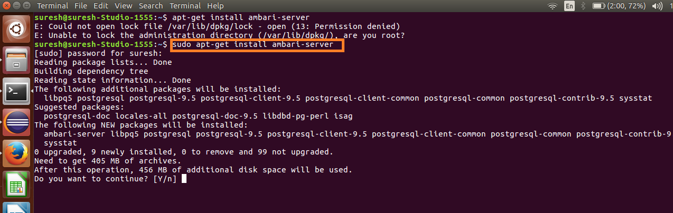

**Server setup: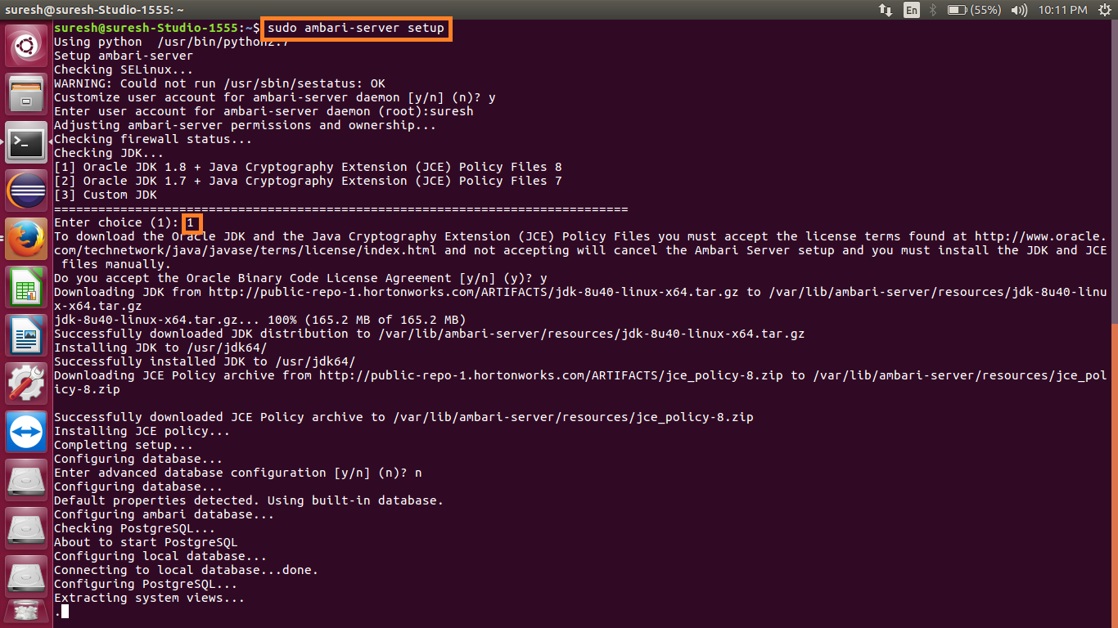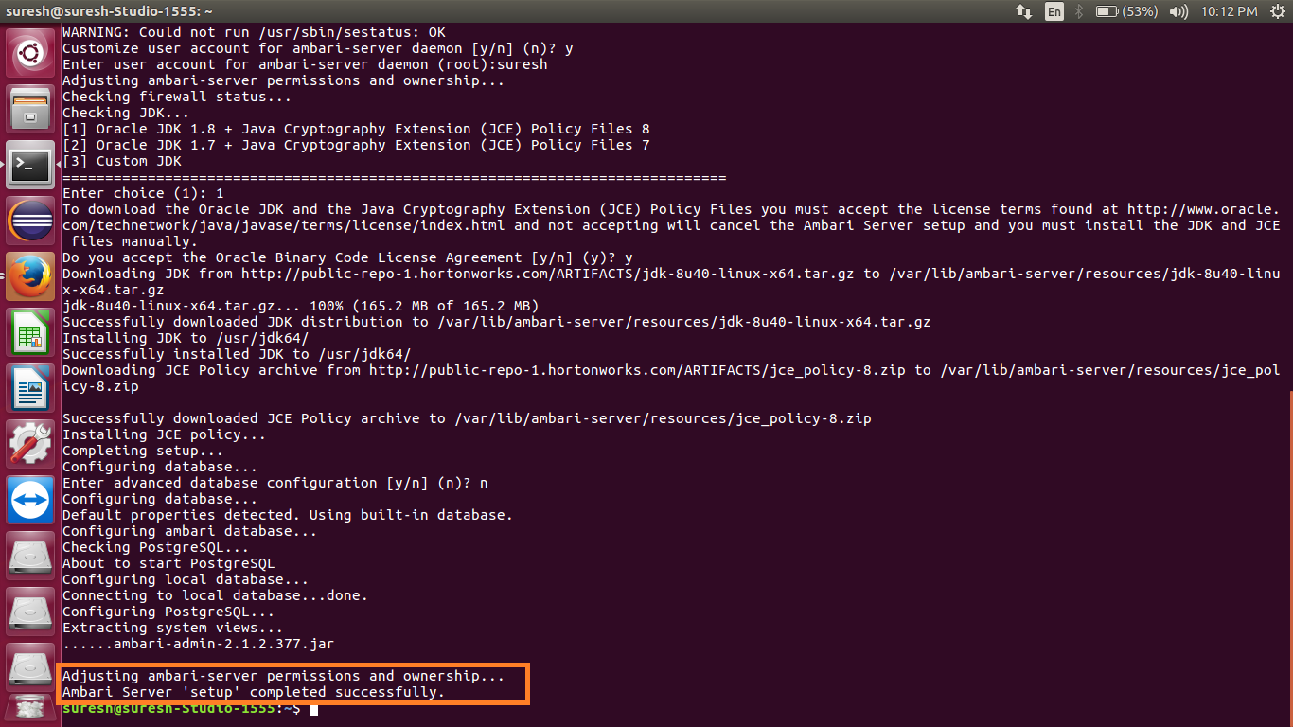**

**Starting ambari server: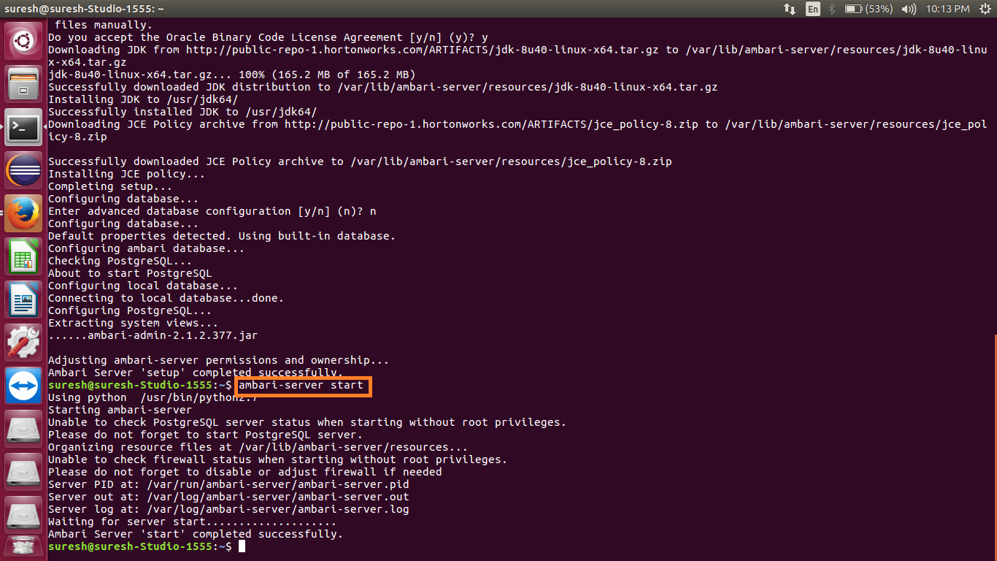**

**Web interface:**

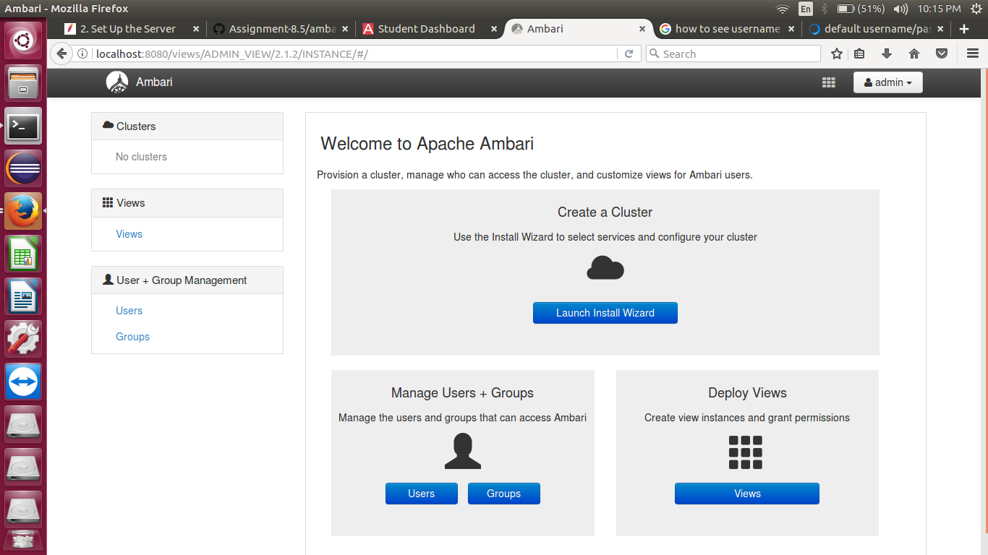

**Ambari Usefulness & features:**

Apache Ambari as a part of the Hortonworks Data Platform allows enterprises to plan, install and securely configure HDP making it easier to provide ongoing cluster maintenance and management, no matter the size of the cluster.

Ambari makes Hadoop management simpler by providing a consistent, secure platform for operational control. Ambari provides an intuitive Web UI as well as a robust REST API, which is particularly useful for automating cluster operations. With Ambari, Hadoop operators get the following core benefits:

* **Simplified Installation, Configuration and Management-**

Easily and efficiently create, manage and monitor clusters at scale. Takes the guesswork out of configuration with [Smart Configs](https://cwiki.apache.org/confluence/display/AMBARI/Enhanced+Configs) and Cluster Recommendations.  Enables repeatable, automated cluster creation with [Ambari Blueprints](https://cwiki.apache.org/confluence/display/AMBARI/Blueprints" \t "_blank).

* **Centralized Security Setup-**

Reduce the complexity to administer and configure cluster security across the entire platform. Helps automate the setup and configuration of advanced cluster security capabilities such as Kerberos and [Apache Ranger](https://hortonworks.com/apache/ranger/).

* **Highly Extensible and Customizable-**

Fit Hadoop seamlessly into your enterprise environment. Highly extensible with[Ambari Stacks](https://cwiki.apache.org/confluence/pages/viewpage.action?pageId=38571133) for bringing custom services under management, and with[Ambari Views](https://cwiki.apache.org/confluence/display/AMBARI/Views) for customizing the Ambari Web UI.

* **Full Visibility into Cluster Health-**

Ensure your cluster is healthy and available with a holistic approach to monitoring. Configures predefined alerts — based on operational best practices — for cluster monitoring. Captures and visualizes critical operational metrics — using [Grafana](http://grafana.org/) — for analysis and troubleshooting. Integrated with[Hortonworks SmartSense](https://hortonworks.com/products/subscriptions/smartsense/) for proactive issue prevention and resolution.